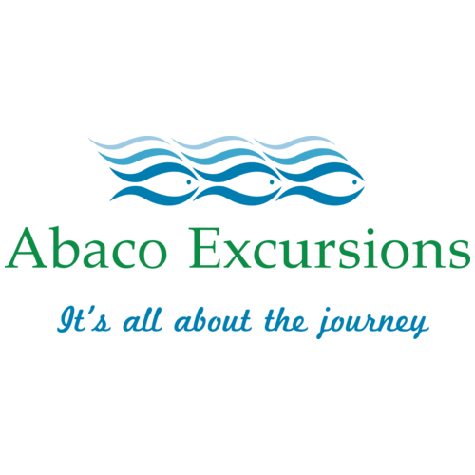

Abaco Excursions agrees to charter Sand Dollar, in solid working condition and provide a licensed Captain and Crew prepared to work to your pre-planned specifications for the day agreed upon.

Guests will not exceed 18 passengers and NO smoking or shoes on the vessel.

All guests waive any liability to Abaco Excursions or On the Water Holdings, LLC regarding any injury or death during the in or out of water activities which may incur during the charter trip.

Any cancellation within 48 hours requires the charter guest to forfeit their 50% deposit.
Same Day cancellations is a 100% forfeiture of the guest day charter fee.
In the event of inclement weather, and the captain determines it will be unsafe or particularly unpleasant, he will work with guests to reschedule their charter day and if that is not possible, we will refund your full payment less any processing fees, cost to secure the crew and catering purchased.

All catering is required 48 hours prior. Charters can order off the catering menu for an additional charge.

Guests will adhere to the Captain's requests regarding safety of the vessel, Crew and passengers.

Any damage caused to the vessel by charter guests will be evaluated, estimated and charged to the charter group.

The Captain agrees to perform the following duties:
Report any deficiencies of the boat used in providing transportation which may cause concern or safety of the passengers.
Maintain control of the boat in a safe and legal manner exhibiting seaman-like qualities at all times.
Do his best to ensure the passengers have a terrific experience on the vessel.

Payment for services will occur with a 50% deposit, 48 hours prior to the charter.
Final payment is due the day prior to the charter.
Half day charters past 5 hours – will be charged the full day rate at the end of the day.
Full day charters beyond 8 ½ hours will be charged $750 per additional hour.
Incremental hourly charges, estimated damage charge and tip will all be settled prior to the end of the charter day.

